 

**Placement Empowerment Program**

***Cloud Computing and DevOps Centre***

**Back Up and Restore a Cloud Instance**Take a snapshot of your cloud VM. Terminate the VM and restore it from the snapshot.

Name: Subiksha R Department : AML



**Introduction**

Cloud platforms like Microsoft Azure provide robust solutions for virtual machine (VM) management, including the ability to take snapshots of disks for backup and recovery. Snapshots capture the entire state of a disk, allowing users to recreate or restore VMs quickly in the event of failure or required migration.

**Overview**

In this task, you will:

1. Take a snapshot of the root (OS) disk of an Azure VM.
2. Delete the VM after ensuring a snapshot has been created.
3. Restore the VM by creating a new virtual machine from the snapshot.
4. Verify that all data, configurations, and applications are intact.

This is a common practice for backup and disaster recovery in cloud environments.

**Objective**

* Learn how to take snapshots of VM disks in Azure.
* Understand how to delete and recreate a VM from a snapshot.
* Verify data integrity and system configuration restoration after VM recovery.

**Step-by-Step Procedure**

**Step 1 : Open the Azure Portal**

* Go to [Azure Portal](https://portal.azure.com/).
* Log in with your credentials and select the correct subscription.

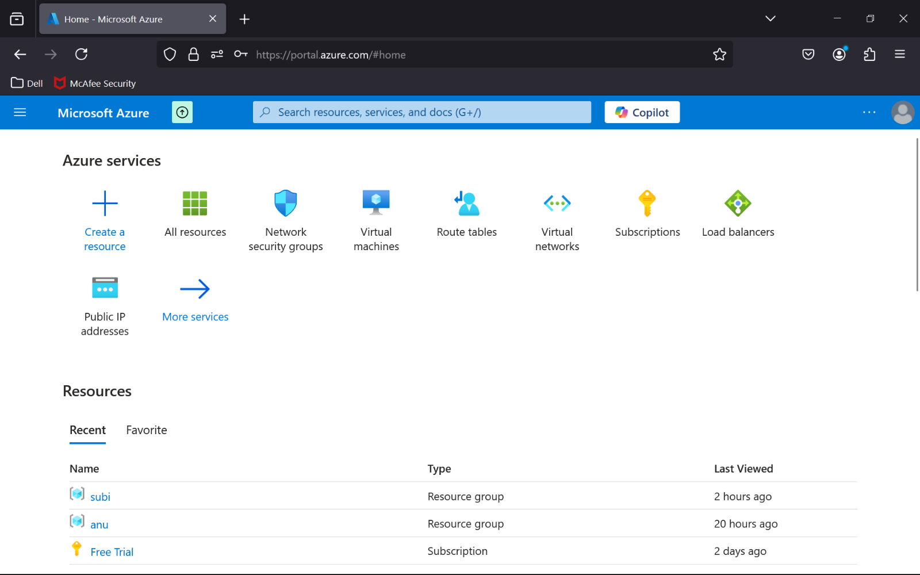

**Step 2 :** Create a Virtual Machine.

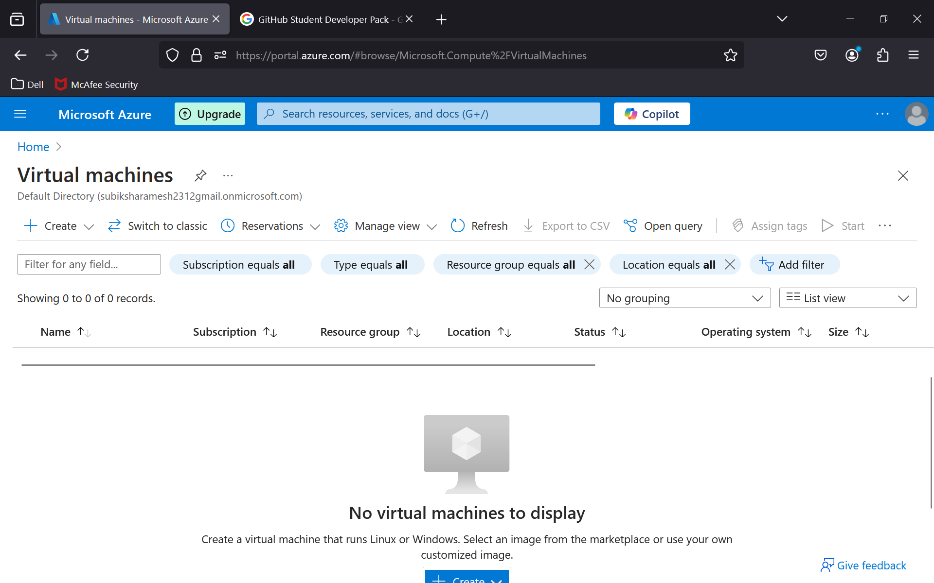

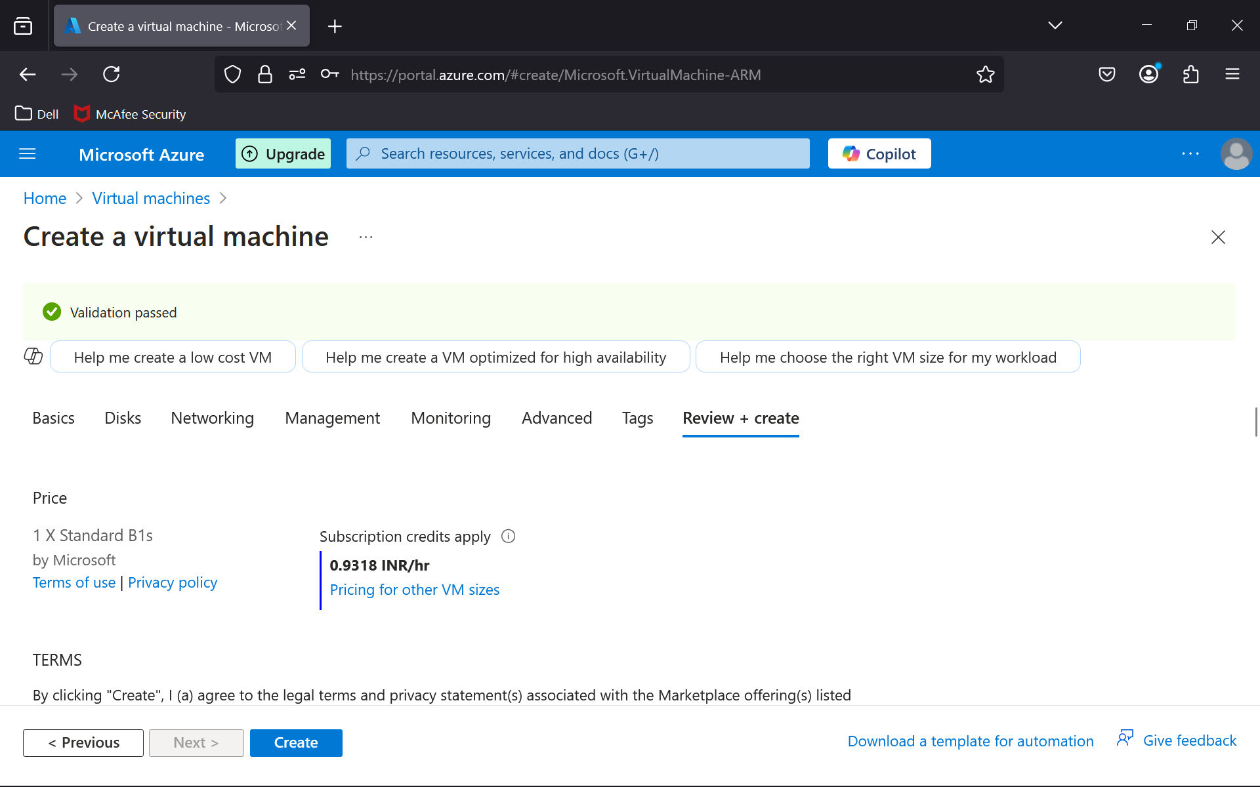

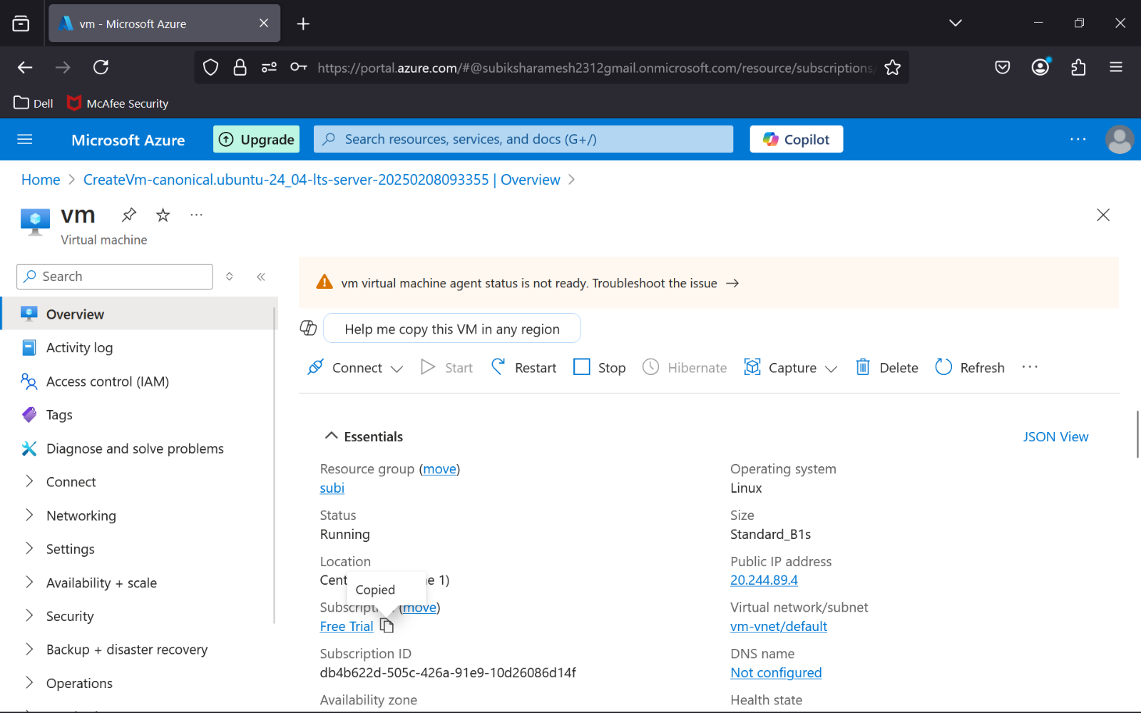

**Step 3 :** Take a Snapshot of the VM's OS Disk

* Navigate to **Virtual Machines** from the left-side menu.
* Select the VM whose disk you want to snapshot.
* Stop the VM (optional but recommended).
* Go to **Disks**, then click the OS disk name.

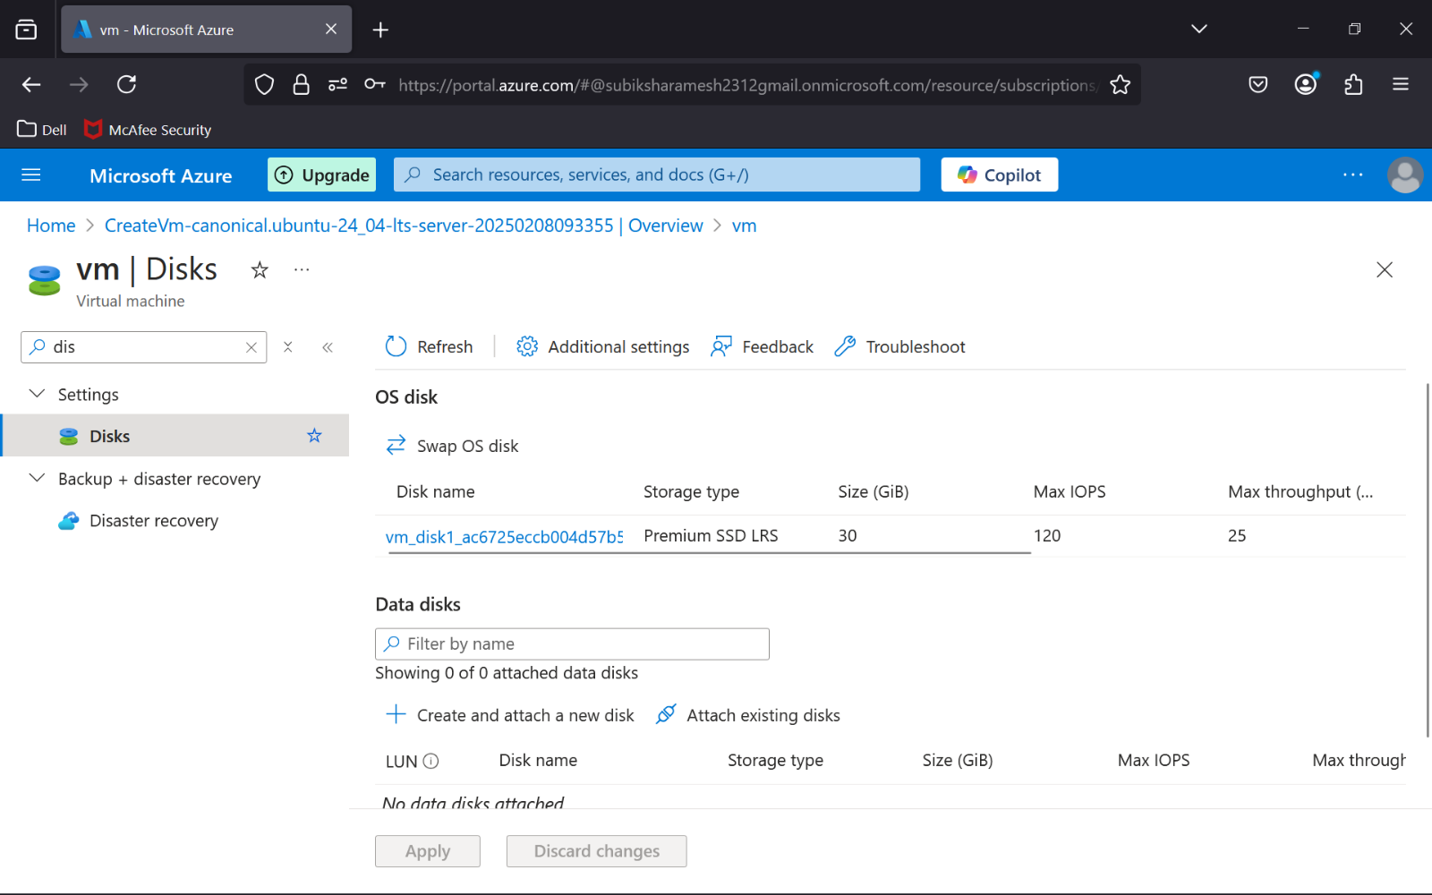

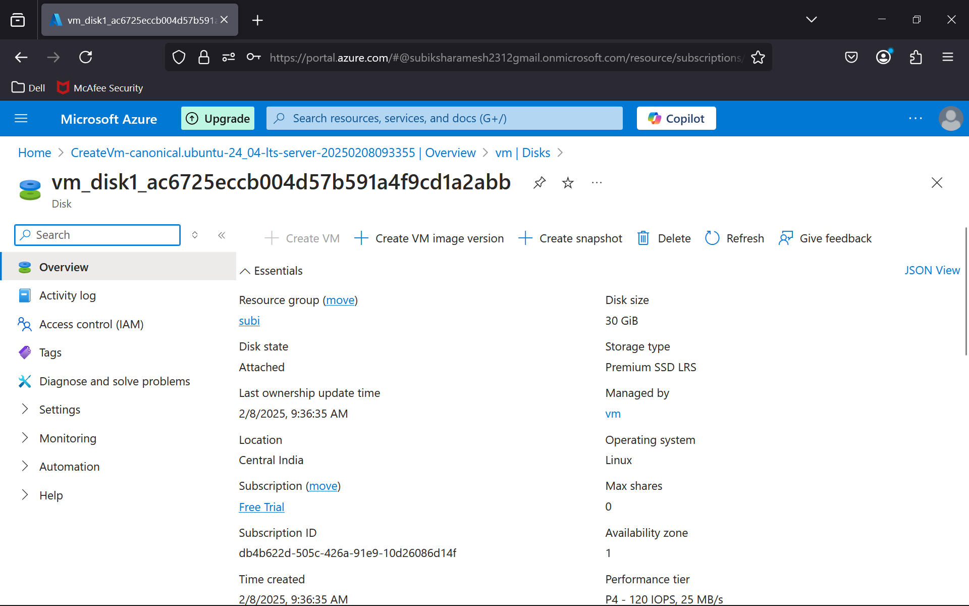

**Step 4 :** Select **Create Snapshot** at the top of the page.

Fill in the details:

* + **Name:** Provide a unique snapshot name.
  + **Snapshot type:** Select **Full (default)**.
  + **Source disk:** Ensure it’s pointing to the correct disk.
* Click **Review + Create**, then **Create**.

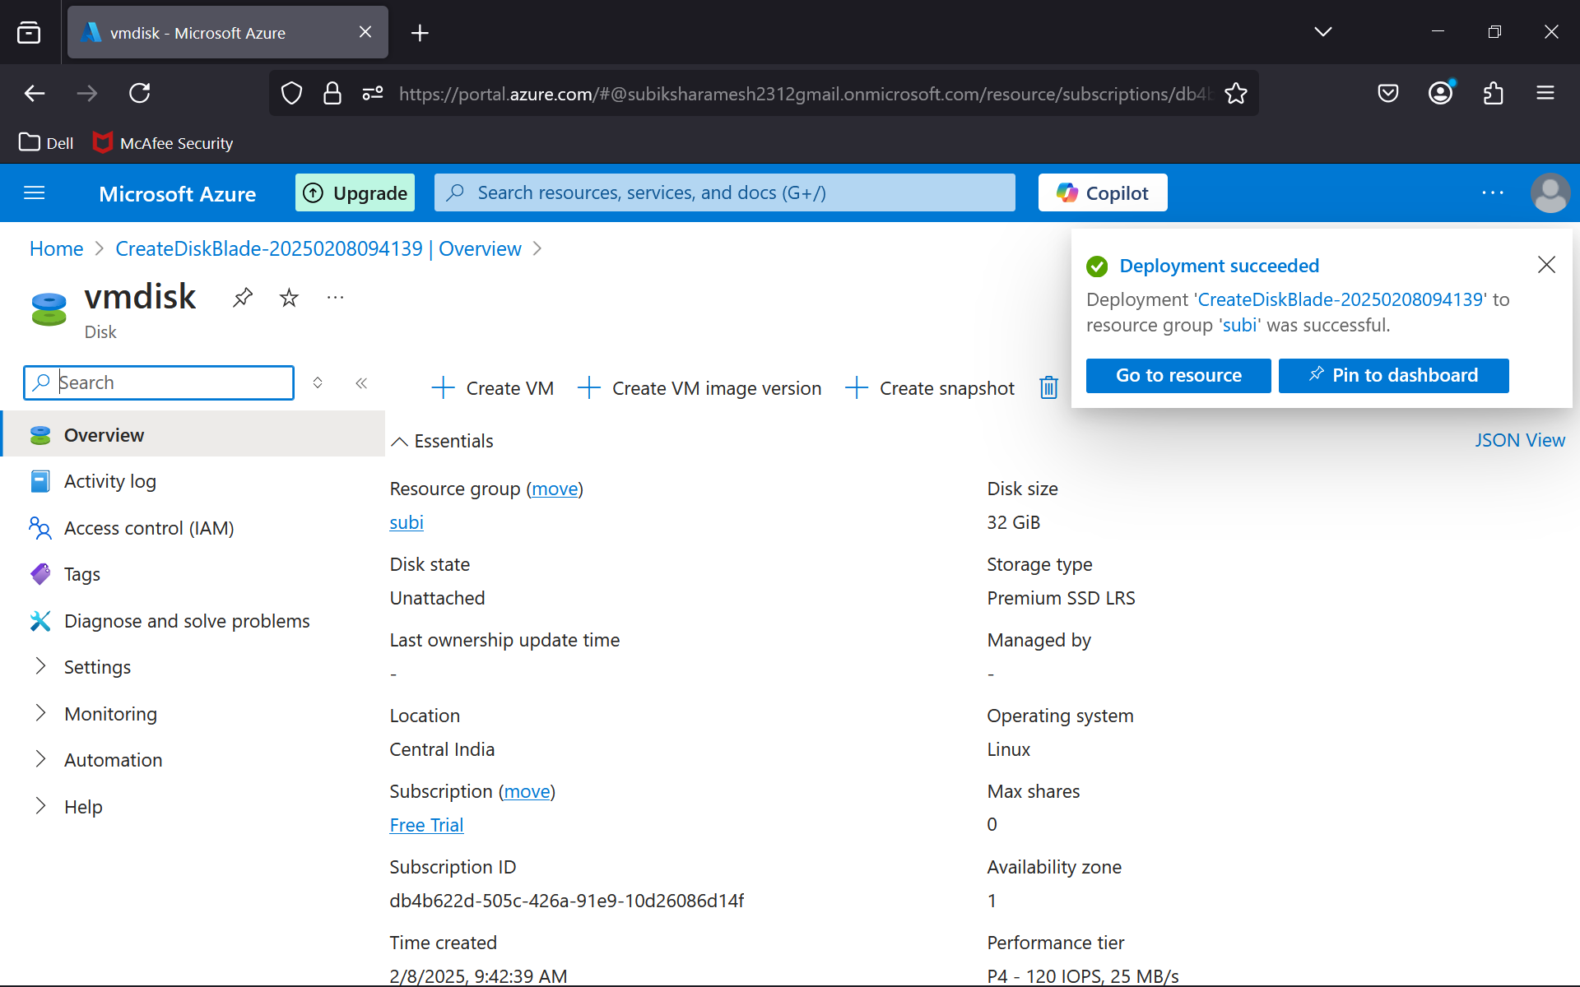

**Step 5 : Delete the Original VM**

* Return to **Virtual Machines**.
* Select the VM and click **Delete**.
* Confirm the deletion.

**Step 6 : Create a New VM from the Snapshot**

* Go to **Disks** and select the snapshot you just created.
* Click **Create Disk** and provide the necessary details (disk name, resource group, etc.).
* Navigate to **Virtual Machines** and click **Create > Virtual Machine**.
* Configure the following settings:
  + **Basics:** Name, resource group, and VM region.
  + **Disks:** Select **Attach existing disk** and choose the disk created from the snapshot.
* Complete the other configuration steps and click **Create**.

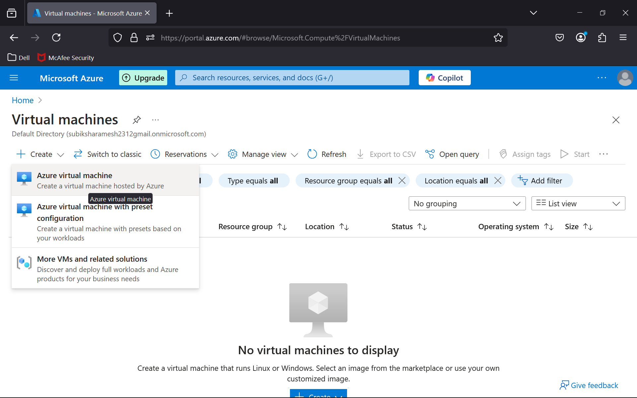

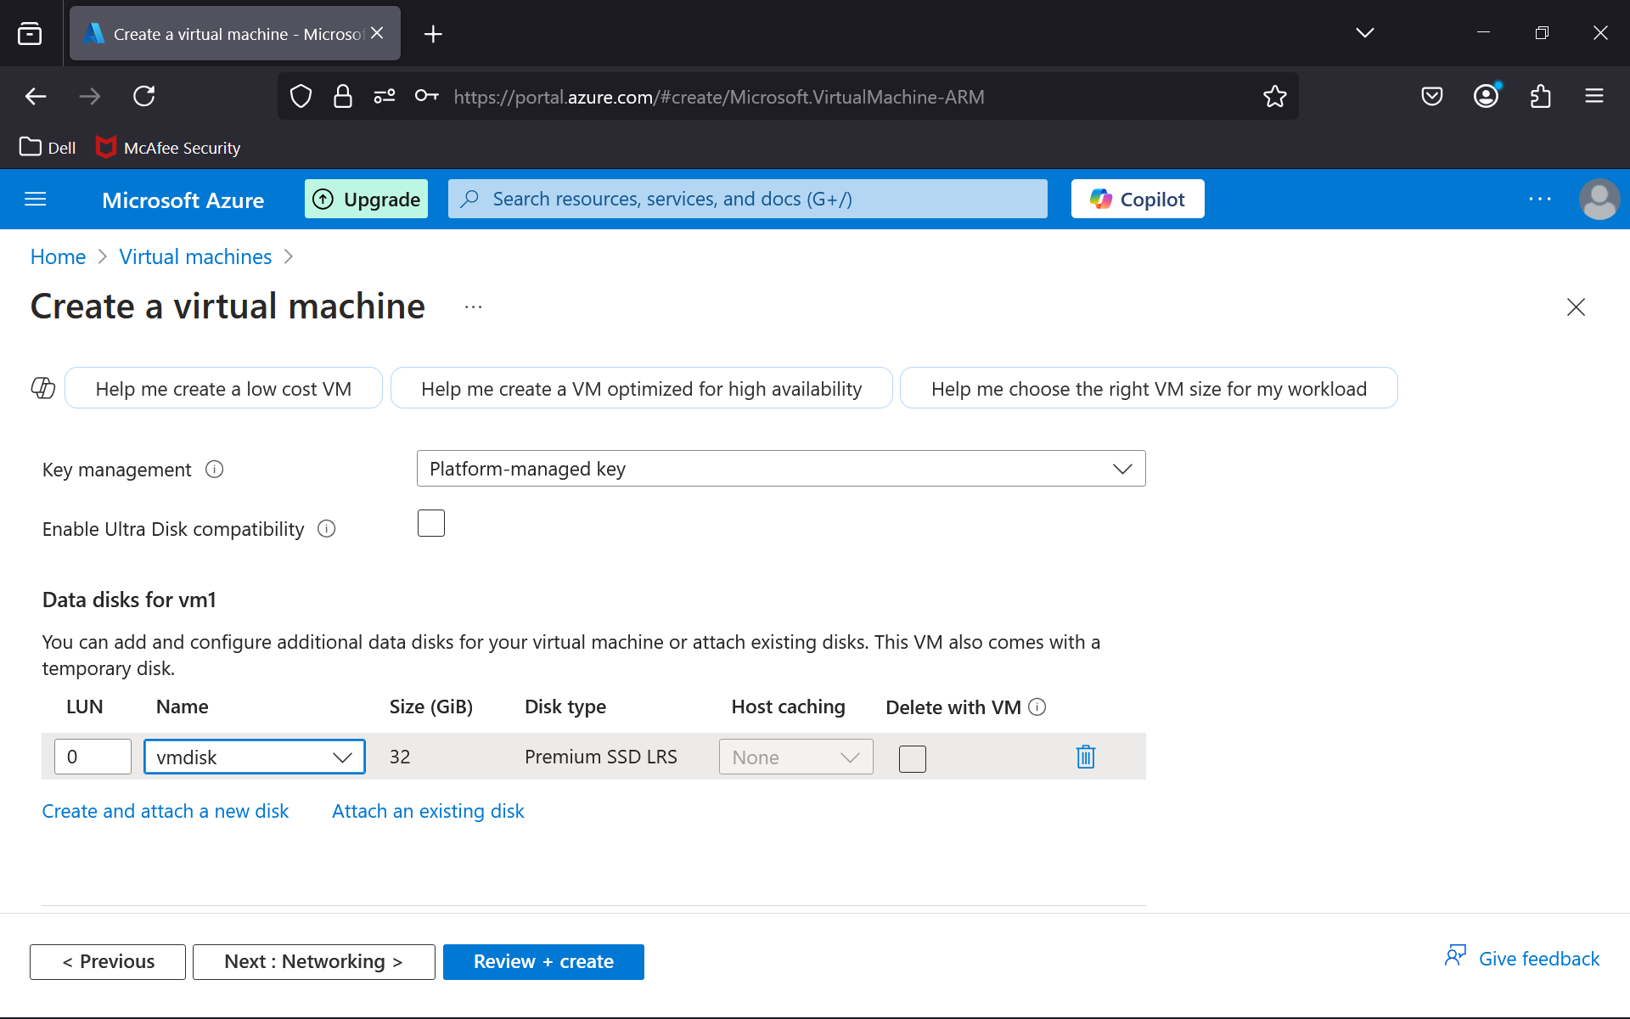

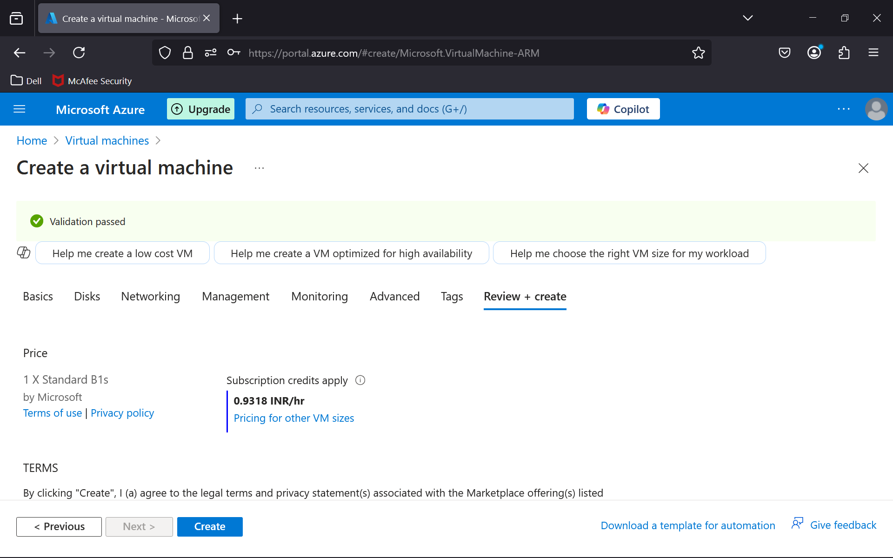

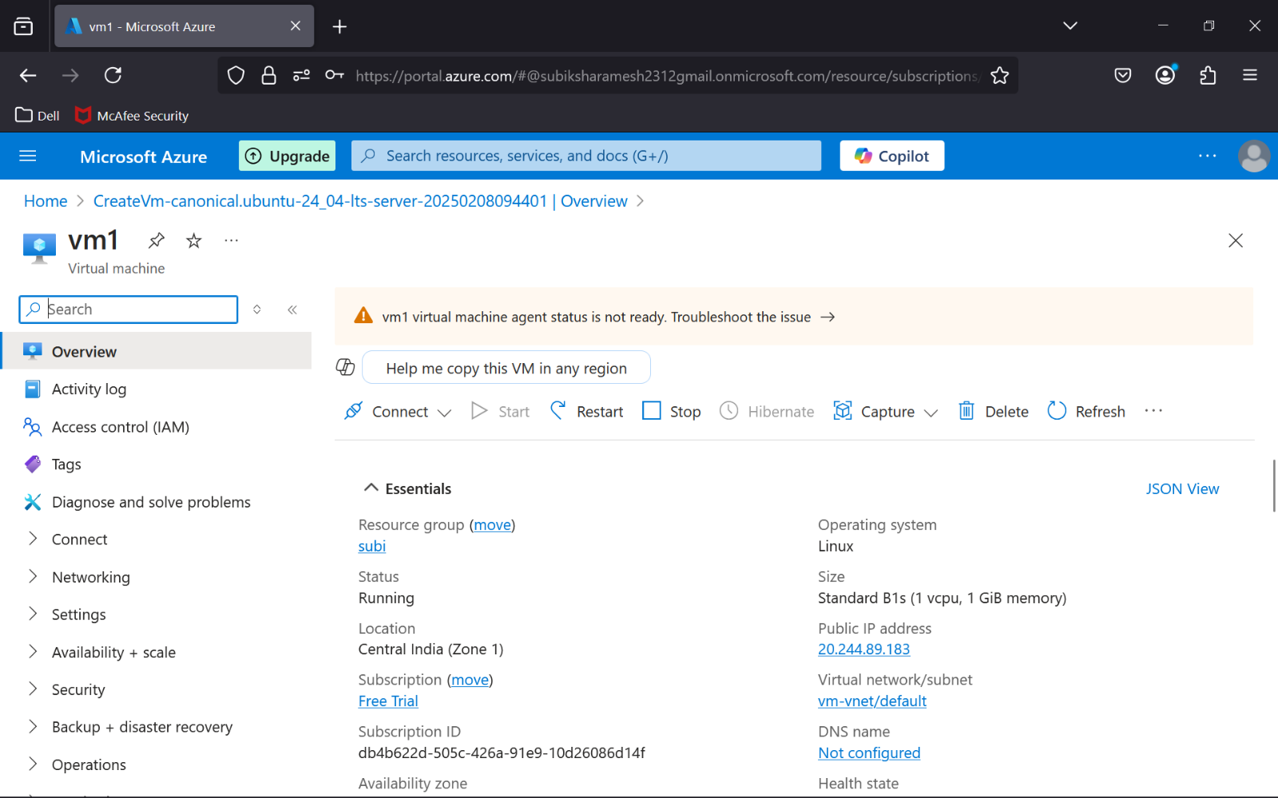

**Step 7 :** Verify Data and Configuration Integrity

* Once the new VM is deployed, connect to it via **RDP** (for Windows) or **SSH** (for Linux).
* Verify the following:
  + Files and directories on the disk are intact.
  + Applications and services are functioning correctly.
  + System configurations and settings are properly restored.

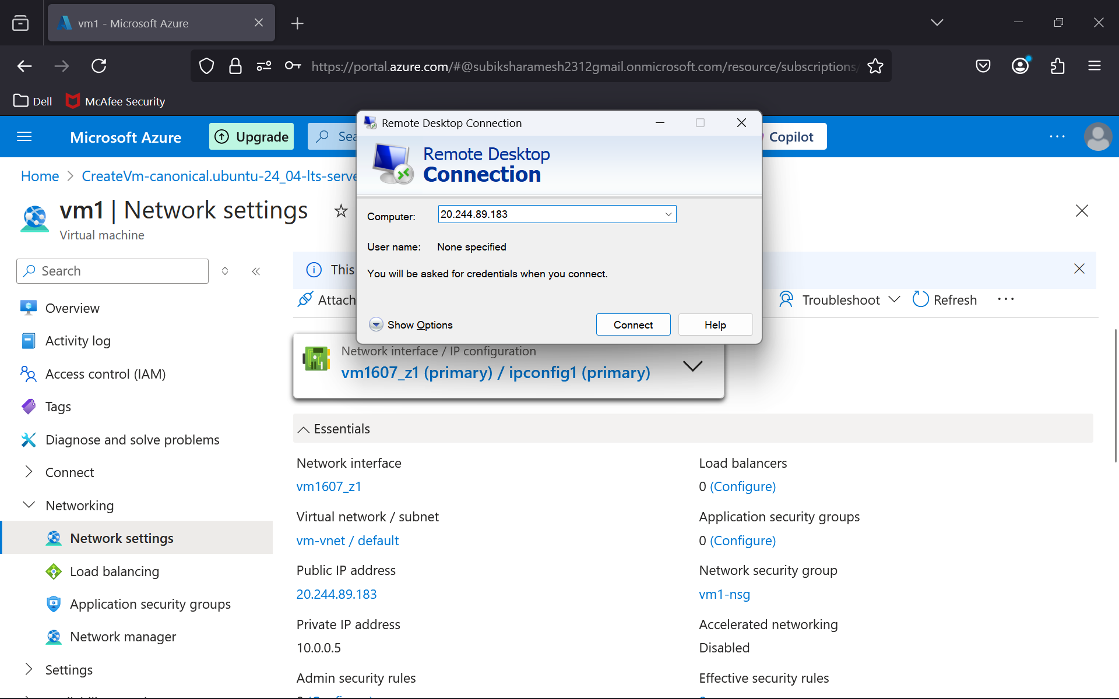

**Outcome**

After following this procedure, you will successfully:

1. Take a snapshot of a VM disk in Azure.
2. Recreate a VM from the snapshot without data or configuration loss.
3. Understand the process of VM recovery and disaster mitigation using snapshots.

This task demonstrates efficient cloud resource management and reinforces key concepts in cloud computing.